The Automatic Exposure Control Tube Current Modulation Curve as a Candidate Signal for Hypertension, Diabetes, and Chronic Kidney Disease: A Two-Hospital Development and Validation Study
Summary Statement.—A curve-shape score derived from the CT scanner's automatic exposure control tube current curve showed a small, mostly non-independent association with hypertension, diabetes, and chronic kidney disease that did not reach significance after correction for multiple comparisons, though a residual signal in one principal component survived adjustment for demographic and CT-adiposity covariates.
Abstract
Background.—Opportunistic CT-derived body-composition biomarkers are associated with cardiometabolic disease, but whether the scanner's automatic exposure control (AEC) tube current modulation curve itself carries comparable information, independent of routinely available clinical and CT-adiposity data, has not been tested.
Purpose.—To evaluate a prespecified, curve-derived AEC shape score as an incremental predictor of hypertension (HTN), diabetes mellitus (DM), and chronic kidney disease (CKD) when added to demographic and CT-adiposity baseline models, using internal development and external validation cohorts.
Materials and Methods.—This retrospective study included an internal development cohort (Gangnam Severance Hospital, 2018–2020, n=1259) and an external validation cohort (Sinchon Severance Hospital, 2019, n=1123). A fixed FPCA-derived AEC score (3 components, selected by an elbow criterion in the internal cohort) was added to two baseline model families: demographics plus mean tube current (Family A) and demographics plus CT-derived visceral and subcutaneous fat area (Family B). Internal performance used stratified 5-fold cross-validation and external performance a single frozen model. AUC increments were tested with paired DeLong tests (24 comparisons; Bonferroni α=.0021, with Benjamini-Hochberg FDR as sensitivity analysis), alongside calibration, reclassification (NRI, IDI), and partial correlation of AEC components with each outcome after adjustment for age, sex, height, weight, and CT-adiposity.
Results.—Adding the AEC score raised AUC in 11 of the 12 outcome-cohort-family combinations tested (median ΔAUC=+0.009). Three of these increments reached nominal significance—HTN external (P=.020), DM internal (P=.012), and CKD external (P=.007)—all within the family that excluded CT-adiposity data; none, however, survived Bonferroni correction, nor did any reach significance by Benjamini-Hochberg FDR (minimum q=.084). Internal calibration remained adequate (slope, 0.93–0.99), whereas external calibration was attenuated overall (slope, 0.40–0.84), most markedly for CKD (slope, 0.40–0.49). Once each AEC component was adjusted for age, sex, height, weight, and CT-adiposity, most of its correlations with outcome no longer held; an exception was the second principal component, which retained a residual association with DM internally (partial r=−0.095, P<.001) and with CKD externally (partial r=−0.103, P<.001).
Conclusion.—The AEC-128 tube current curve carried only a small, largely non-independent signal for hypertension, diabetes, and chronic kidney disease, one that did not survive correction for multiple comparisons. A modest residual association in a single curve component remained after adjustment for demographic and CT-adiposity covariates but was not consistent across the two cohorts, so rather than supporting the curve's standalone clinical use at this stage, the finding points to a target for further study.

Introduction
Opportunistic analysis of CT scans acquired for clinical indications other than cardiometabolic risk assessment has emerged as a paradigm for population-level cardiometabolic risk stratification: automated measures of visceral and subcutaneous fat, skeletal muscle, hepatic fat, bone density, and vascular calcification have repeatedly been shown to predict diabetes and related comorbidities without additional radiation exposure (1–3). However, virtually all such biomarkers have been derived from the reconstructed images themselves. One signal generated on nearly every clinical CT scan—yet largely unexplored as a candidate biomarker—is the scanner's automatic exposure control (AEC) tube current modulation curve.
During acquisition, the scanner continuously adjusts tube current (mA) along the z-axis to maintain target image quality as the patient's cross-sectional attenuation changes from chest to pelvis (4,5). Because this modulation is driven directly by the patient's attenuation profile, the resulting curve implicitly encodes body habitus and regional tissue composition (6–8)—the same characteristics that, when measured directly using CT-based body-composition metrics, are consistently associated with diabetes, hypertension, and related cardiometabolic risk factors (1), metabolic syndrome (9), and chronic kidney disease (10). If the AEC curve meaningfully reflects this composition, it should, in principle, carry diagnostic information relevant to these same conditions as a byproduct of scans already being performed.
Despite this plausible link, prior studies of the AEC curve and tube current modulation have focused almost exclusively on radiation dose—validating z-axis modulation (4), cataloging dose-management tools (5), deriving size-specific dose estimates (6–8), or, most recently, predicting organ-level dose from scout and tube current data using deep learning (11)—without testing whether the curve carries diagnostic information independent of dose. To our knowledge, its value as an opportunistic biomarker has not been directly examined.
This study therefore evaluated the AEC-128 tube current modulation curve as a candidate biomarker for hypertension, diabetes, and chronic kidney disease. We tested whether adding a curve-derived shape score to clinical models of increasing complexity—a minimal demographic model and models further incorporating either scan-level tube current information or CT-based adiposity—improved classification performance in an internal development cohort and a fixed external validation cohort.
Materials and Methods
[PLACEHOLDER] This retrospective study was approved by the institutional review boards of Gangnam Severance Hospital and Sinchon Severance Hospital (IRB No. ______ and ______), and the requirement for written informed consent was waived — *insert the actual IRB approval numbers before submission; confirm official English hospital names.*
Patients
We used two tertiary-hospital cohorts from different institutions with different scanner configurations: an internal development cohort (Gangnam Severance Hospital) and a cross-site external validation cohort (Sinchon Severance Hospital). Scans were acquired between 2018 and 2020 at Gangnam Severance Hospital and in 2019 at Sinchon Severance Hospital.
Examinations were then sequentially excluded according to missing height or weight in the clinical database, age <20 years, height/weight/body mass index (BMI) outliers by the interquartile-range rule, other missing clinical variables, and AEC signal curve-validity criteria (see Appendix S1 for detailed criteria; per-criterion counts are shown in Figure 1).
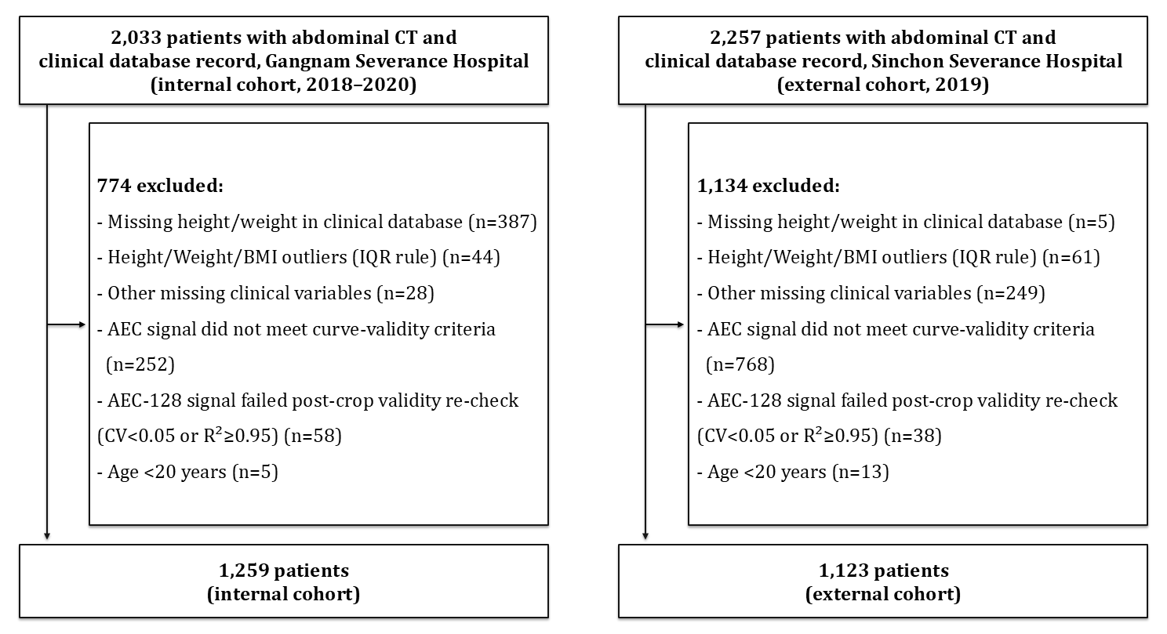Figure 1. Patient selection flowchart for the internal (Gangnam Severance Hospital) and external (Sinchon Severance Hospital) cohorts.
Measurements
CT Image Acquisition.—During each patient's abdominopelvic CT examination, the scanner recorded an automatic exposure control (AEC) tube current (mA) modulation curve, adjusted in real time along the z-axis (craniocaudal slice position) to maintain constant image quality; this curve reflects the patient's cross-sectional attenuation at each position, which is jointly determined by body habitus, intravenous contrast enhancement, patient positioning within the gantry, and scanner-specific acquisition and reconstruction settings. Each patient's CT series was filtered to retain only the true axial series, and the pubis–liver z-axis segment was established by TotalSegmentator (12)-based landmark detection.
AEC-128 Curve Derivation.—Tube current values within the established pubis–liver z-axis segment were linearly interpolated and resampled to 128 points to yield a standardized analysis unit, the AEC-128 curve; as an opportunistic signal obtained as a byproduct of CT scans acquired for clinical indications, this required no additional radiation exposure. A single, disease-agnostic AEC score was subsequently derived by fitting functional principal component analysis (FPCA) (13–15) to the AEC-128 curves of the internal cohort, retaining the first k principal components selected—based not on performance but on a Kneedle/elbow criterion (16) applied to the scree curve of individual explained-variance ratios (Figure 2). This prespecified, disease-agnostic AEC score (FPCA PC1–k) was then applied identically to all outcomes and models; no disease-specific reselection of curve-based candidates was performed.
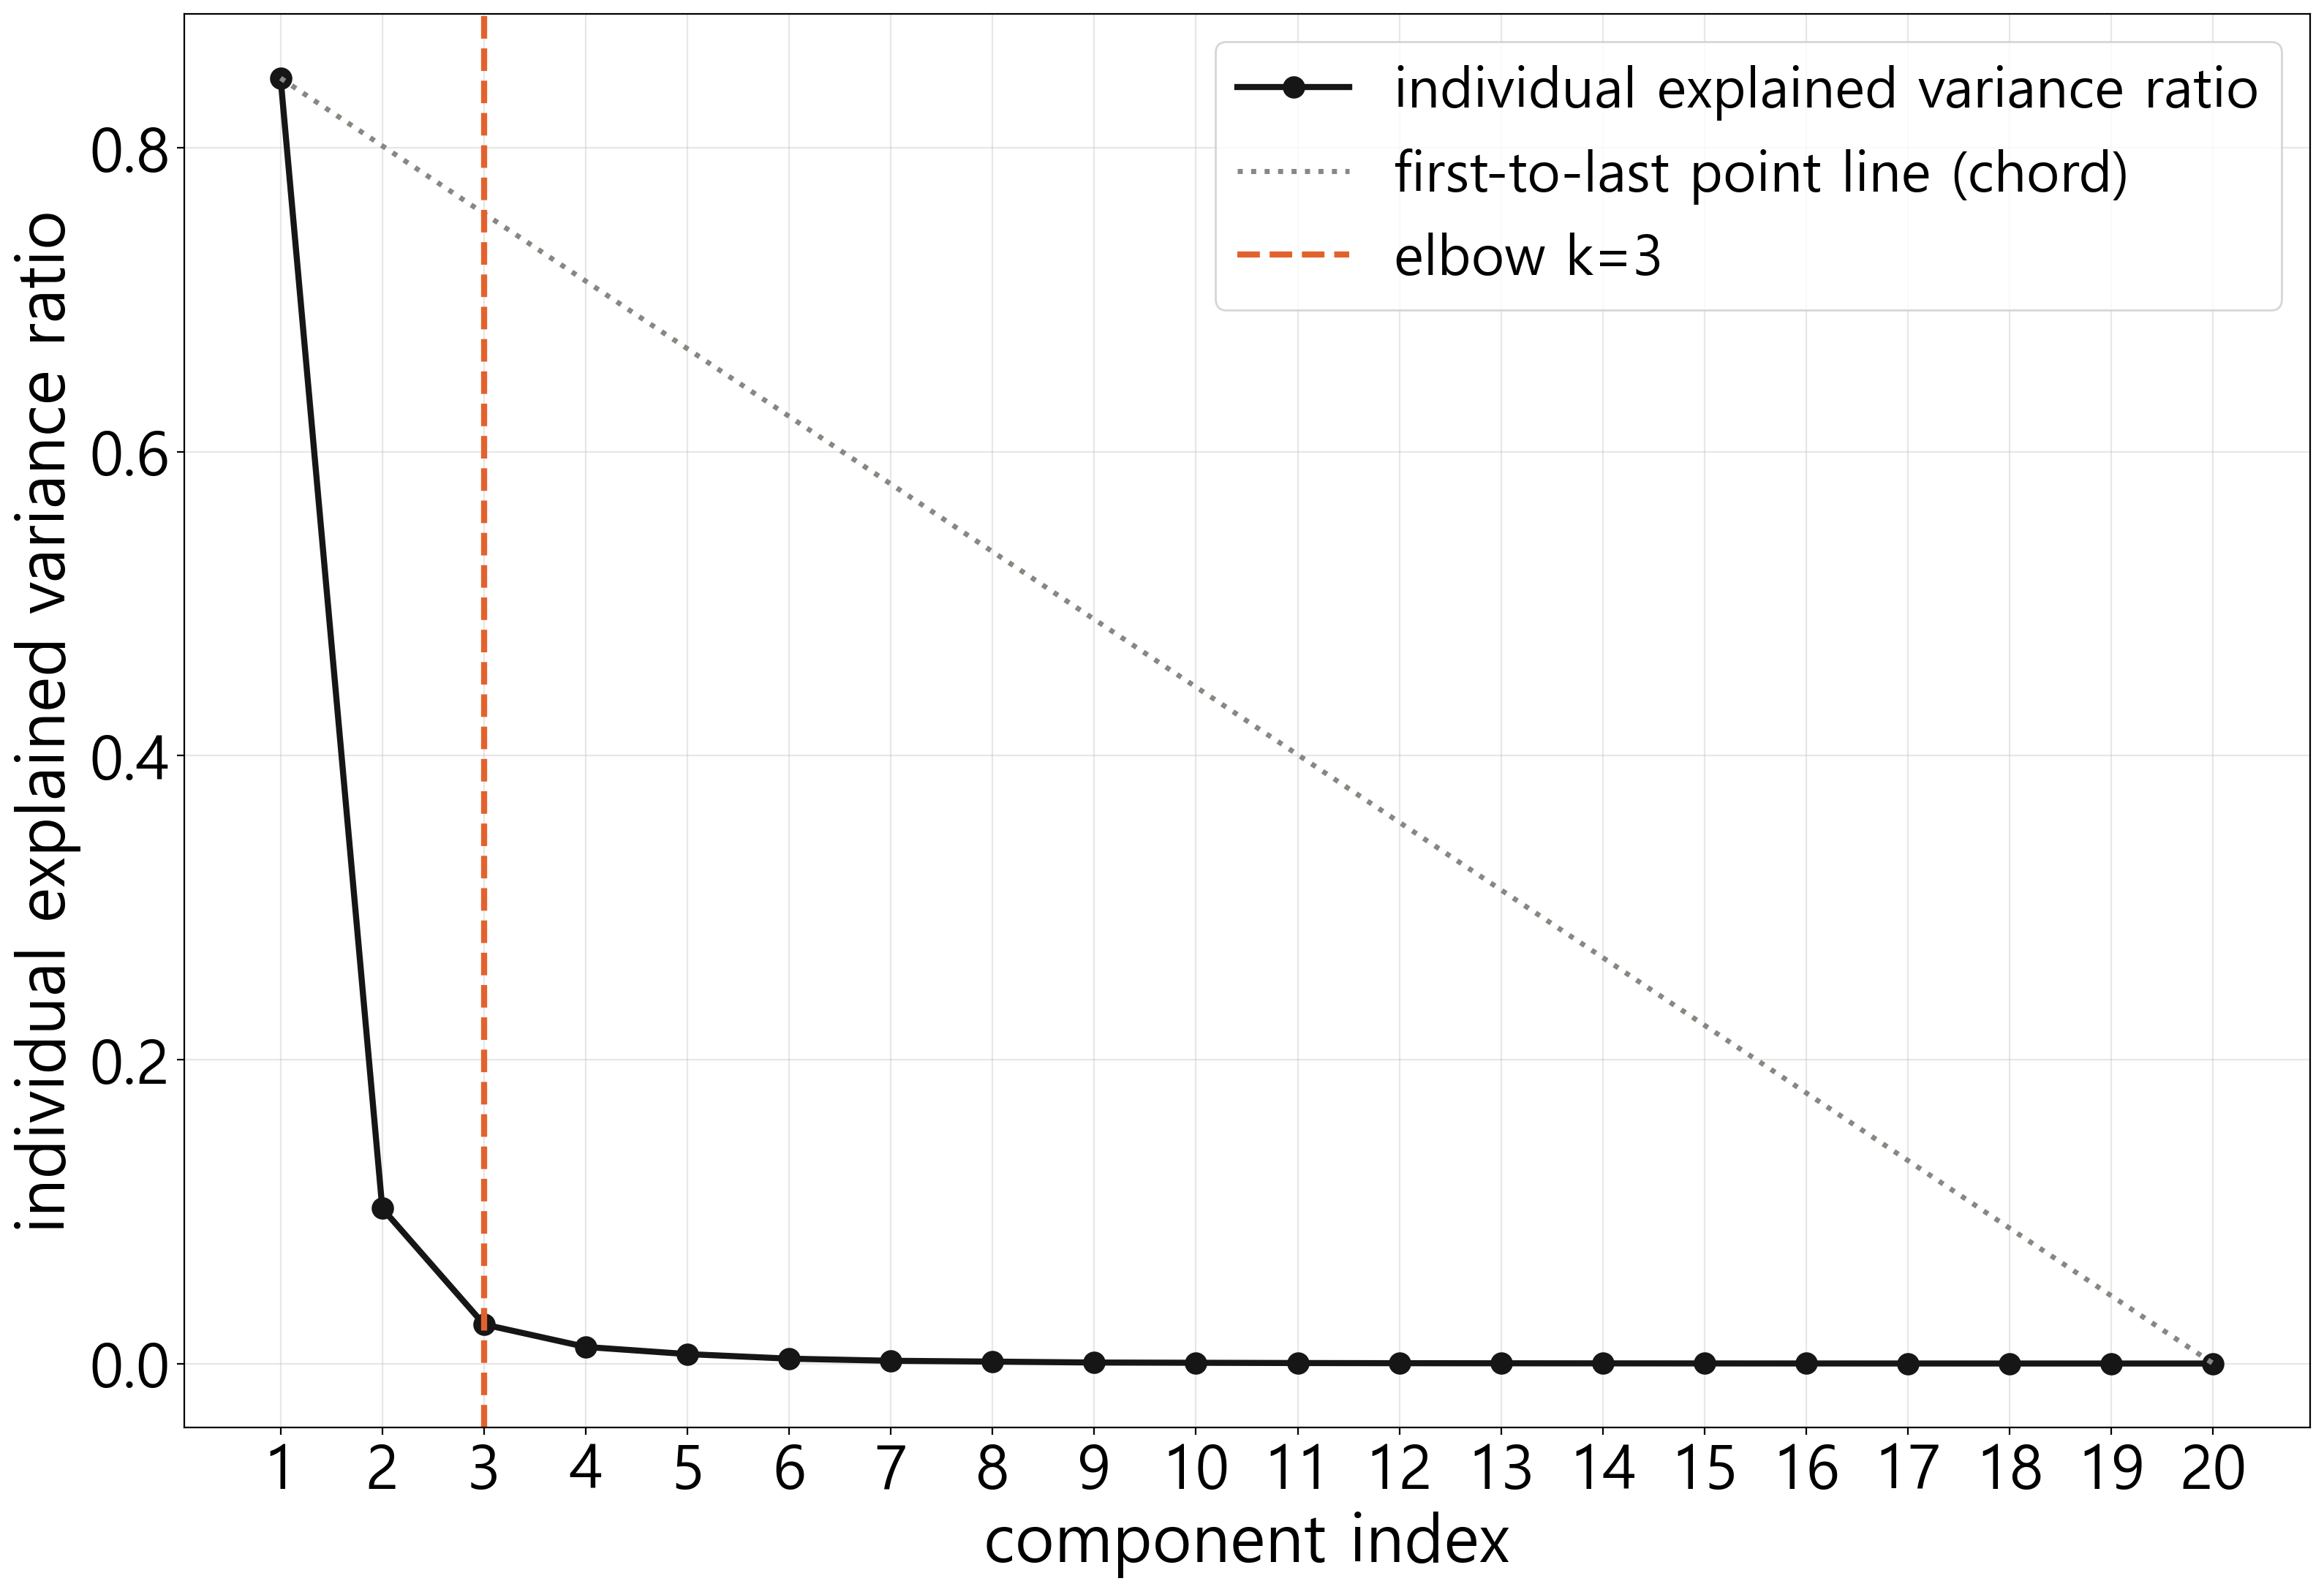Figure 2. Scree plot used to select the number of FPCA components. The curve of individual explained-variance ratios (solid line) shows an inflection at component k=3, identified as the point of maximum perpendicular distance from the chord connecting the first and last points (dashed line), per the Kneedle/elbow criterion. This fixed value (FPCA PC1–3) was applied identically to all outcomes and models.
Automated Body Composition Analysis (VAT, SAT).—Visceral (VAT) and subcutaneous (SAT) adipose tissue cross-sectional areas were quantified within the same pubis–liver z-axis segment used to derive the AEC-128 curve, using TotalSegmentator's dedicated tissue-composition task (tissue_4_types), which outputs anatomic torso-fat (visceral) and subcutaneous-fat compartment masks; each compartment mask was further restricted to fat-range attenuation values (−190 to −30 Hounsfield units [HU]) before voxel counting. For each patient, the number of SAT and VAT voxels within this segment was multiplied by the in-plane pixel area (cm²) and summed across all included slices to yield a single cross-sectional area sum for each of SAT and VAT.
Clinical Variables (Clinic4).—Age, sex, height, and weight—collectively termed "clinic4"—were extracted from the same clinical database as the baseline clinical predictor set; sex was coded as a binary indicator (male=1).
Outcome Variables (HTN, DM, CKD).—Outcomes were binary diagnoses of hypertension (HTN), diabetes mellitus (DM), and chronic kidney disease (CKD), determined from the International Classification of Diseases, 10th Revision (ICD-10) diagnostic history in the same clinical database used for cohort selection, without restriction on diagnosis date relative to the CT scan; this label therefore reflects cumulative, ever-diagnosed status rather than status at the time of scanning. [PLACEHOLDER: list the specific ICD-10 code ranges used to define each outcome, and state whether medication-based case definitions (e.g., antihypertensive, insulin, or oral hypoglycemic prescriptions) were also used, before submission.]
Statistical Analysis
Descriptive Statistics.—Baseline characteristics of the internal and external cohorts were summarized: normally distributed continuous variables were expressed as mean±SD and compared with Welch's t test, non-normally distributed continuous variables (VAT, SAT) were expressed as median (IQR) and compared with the Mann-Whitney U test, and categorical variables were expressed as frequencies and percentages and compared with the chi-square test.
Predictor Sets and Standardization.—To contextualize the incremental value of the AEC score against progressively more informative baseline models, we defined two additional predictor sets: (1) mean_mAs, the patient-level mean of the raw AEC-128 curve, reflecting scan-level dose/technique information without curve shape; and (2) VAT+SAT, an absolute (not ratio-based) CT-derived measure of adiposity. Age, height, weight, and, where included, mean_mAs/VAT/SAT were standardized (z-score) using parameters fitted in the internal cohort, which were then fixed and applied unchanged to the external cohort.
Model Structure (Nested Logistic Regression).—For each outcome (HTN, DM, CKD), we compared two three-step nested logistic regression model families: family A progressed from clinic4 to clinic4+mean_mAs to clinic4+mean_mAs+AEC score, and family B progressed from clinic4 to clinic4+VAT+SAT to clinic4+VAT+SAT+AEC score. This design separately evaluated the contribution of the AEC score against a scan-technique baseline model (mean_mAs) and a CT-adiposity baseline model (VAT/SAT).
Model Validation (Cross-Validation and External Evaluation).—Stratified 5-fold cross-validation (automatically reduced when class counts were small) was applied to the internal cohort, and internal area under the receiver operating characteristic curve (AUC) was calculated from out-of-fold (OOF) predicted probabilities. For models including the AEC score, FPCA and the standardization scaler were each refit independently within the training partition of each fold, to prevent information leakage from the validation fold into eigenfunction estimation. The external cohort was scored once, using a single fixed model trained on the entire internal cohort. To make internal and external uncertainty directly comparable, we additionally report fold-level internal AUC (mean±SD across folds) and a percentile bootstrap 95% CI for the pooled internal OOF predictions, computed identically to the external bootstrap CI described below.
AUC Comparison and Multiplicity Correction.—AUC differences between adjacent model pairs within each model family were tested with the paired-sample DeLong test (17,18) separately in the internal and external cohorts, yielding 4 nested comparisons per outcome per cohort and 24 comparisons overall (3 outcomes × 4 comparisons × 2 cohorts). Two-sided P<.05 was considered nominally significant; because the 24 tests are not fully independent (nested model chains share cohorts and reference models), Bonferroni correction (α/24=.0021) was used as the primary multiplicity-adjusted threshold, and Benjamini-Hochberg false discovery rate (FDR) q-values were additionally computed as a sensitivity analysis. 95% CIs for external AUC, and for the pooled internal OOF AUC described above, were derived by percentile bootstrap (3,000 resamples; resamples containing only one class were excluded).
Calibration and Reclassification.—Model calibration was assessed with the calibration slope and intercept (from a logistic regression of outcome on the logit of predicted probability) and the Brier score, computed separately for each model, outcome, and cohort. Whether improvements in discrimination translated into patient-level reclassification was assessed with continuous net reclassification improvement (NRI) and integrated discrimination improvement (IDI) for each adjacent model pair; because continuous NRI can overstate clinical improvement when probability shifts are small (22,23), IDI was treated as the primary reclassification metric and NRI as a secondary, exploratory measure.
Threshold-Based and Scanner-Subgroup Metrics.—Classification thresholds were fixed at the point maximizing Youden's J index (19) on each model's internal OOF receiver operating characteristic (ROC) curve and then applied to the external cohort to calculate sensitivity, specificity, and accuracy. To assess dependence on scanner model, existing predicted probabilities were re-stratified by scanner manufacturer subgroup, without retraining, and AUC was recalculated within each subgroup; subgroups with fewer than 5 outcome-positive patients are reported as not reportable (NR), given the instability of AUC estimated from very few events.
Redundancy and Collinearity Assessment.—Whether the AEC score was simply redundant with VAT and SAT was assessed with Pearson correlation coefficients between AEC components (FPCA PC1–k) and each tissue area in each cohort, and the correlation between mean_mAs and VAT/SAT was assessed likewise. To test whether any AEC-outcome association was independent of demographic and CT-adiposity information rather than a residual proxy for it, each AEC component was regressed on age, sex, height, weight, VAT, and SAT, and the residual was correlated with each outcome (partial correlation). Variance inflation factors (VIF) were computed for the combined design matrix (age, height, weight, VAT, SAT, and FPCA PC1–k) to assess multicollinearity.
Sample Size and Analysis Software.—This study used an already-established clinical database; sample size was determined by including all patients meeting the selection criteria, without a priori power calculation. This study followed applicable items of the TRIPOD reporting guideline for multivariable prediction model studies (24). Statistical and computational analyses were performed by one author (J.C.), who had full access to the underlying data and takes responsibility for the integrity of the analysis [PLACEHOLDER: confirm whether a second author independently verified the analysis code and key results before submission]. Analyses used Python 3.13.9 (scikit-learn 1.7.2, SciPy 1.16.2, NumPy 2.2.6, pandas 2.3.3).
Results
Patient Characteristics
After sequential exclusion (Figure 1), 1,259 patients formed the internal cohort and 1,123 formed the external cohort (Table 1). The external cohort was slightly older and had a higher proportion of men (both p<.001); height, weight, VAT, and SAT also differed modestly between cohorts (p≤.011, except weight p=.42; Table 1). Mean AEC-128 tube current (mean_mAs) differed substantially by site (204.1±84.1 mA externally vs 312.5±85.9 mA internally, p<.001), reflecting the different scanner configurations by design. All three outcomes were more prevalent externally: hypertension 45.1% vs 30.6%, diabetes 29.8% vs 18.4%, and chronic kidney disease 16.7% vs 8.3% (all p<.001).
Applying the prespecified elbow criterion to the internal cohort (Figure 2) selected k=3 functional principal components, which together captured 97.4% of the cumulative variance in the AEC-128 curve (vs 84.6% for the first component alone); this fixed 3-component AEC score (FPCA PC1–3) was applied unchanged to every subsequent model, outcome, and cohort. The AEC components correlated only weakly to moderately with the CT-derived fat depots against which they were compared: in the internal cohort, Pearson |r| with VAT ranged from 0.17 (PC3) to 0.52 (PC2), and with SAT from 0.08 (PC2) to 0.35 (PC3); external-cohort correlations were smaller (|r|=0.11–0.30 for both depots). No component-tissue pair shared more than 27% of variance (r²), indicating that the AEC score is not a simple proxy for VAT or SAT.

Table 1. Baseline characteristics of the internal and external cohorts.
Characteristic | Internal (n=1259) | External (n=1123) | P value
Demographics
Age (years)* | 57.3 ± 12.1 | 59.7 ± 12.3 | <.001
Male sex, n (%) | 475 (37.7%) | 547 (48.7%) | <.001
Anthropometry
Height (cm)* | 162.8 ± 8.0 | 163.7 ± 8.3 | 0.0104
Weight (kg)* | 62.0 ± 10.1 | 62.4 ± 10.1 | 0.4177
CT-derived measures
VAT (cm2)† | 7524.9 (4538.9–11342.9) | 8561.4 (5103.8–12366.4) | 0.0017
SAT (cm2)† | 18305.5 (13971.1–23306.2) | 17220.1 (11678.2–23237.8) | <.001
Mean tube current, (mA)* | 312.5 ± 85.9 | 204.1 ± 84.1 | <.001
Comorbidities, n (%)
HTN | 385 (30.6%) | 507 (45.1%) | <.001
DM | 232 (18.4%) | 335 (29.8%) | <.001
CKD | 105 (8.3%) | 188 (16.7%) | <.001
Note.—Continuous variables marked * were compared with the Welch t-test (mean ± SD reported) and variables marked † with the Mann-Whitney U test (median [IQR] reported); categorical variables were compared with the chi-square test.

Discriminative Performance of the AEC Score
Figures 3–4 summarize the nested-model comparisons for both model families (Table S1 provides the full numeric results). Adding the covariate step alone (clinic4→+mean_mAs or clinic4→+VAT+SAT) changed AUC negligibly for mean_mAs (ΔAUC −0.002 to +0.002, all P≥.07) and modestly for VAT+SAT (ΔAUC +0.001 to +0.017), with the single nominally significant covariate effect internal for hypertension (ΔAUC=+0.017, 0.794→0.811, DeLong p=.005). Adding the AEC score on top of either covariate produced a positive ΔAUC in 11 of 12 outcome-cohort-family combinations (median +0.009; range −0.0003 to +0.020), the sole exception being hypertension in the internal VAT+SAT family (0.811→0.810, ΔAUC=−0.0003), where clinic4+VAT+SAT alone had already reached AUC=0.811. The AEC increment was largest, and nominally significant, in three combinations, all within the mean_mAs-only family (Family A): hypertension, external (0.718→0.730, p=.020), diabetes, internal (0.721→0.741, p=.012), and chronic kidney disease, external (0.614→0.630, p=.007); the equivalent Family B (VAT+SAT) increments were smaller and did not reach p<.05 in any outcome (closest: diabetes, internal, 0.723→0.735, p=.050). After Bonferroni correction for the 24 prespecified DeLong comparisons (α=.05/24=.0021), none of the 24 comparisons — including these three — reached the corrected threshold. As a sensitivity analysis, Benjamini-Hochberg FDR q-values were computed for the same 24 comparisons (Table S2); none reached significance under this less conservative criterion either (minimum q=.084), indicating the null result after correction is not an artifact of Bonferroni's conservatism specifically. Bootstrap 95% CIs for external AUC widened rather than shifted decisively with AEC addition (e.g., hypertension: 0.687–0.749 vs 0.705–0.764), and fold-to-fold internal AUC was stable across all 15 model-outcome combinations (SD 0.009–0.050), both consistent with the DeLong results above. Fitted coefficients and odds ratios for the fullest model in each family are reported in Table S8.
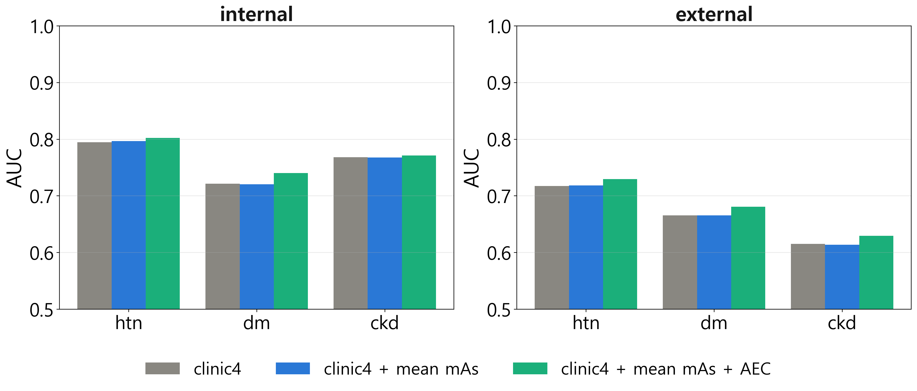Figure 3. Internal (left) and external (right) AUC for the three-step Family A nested model (clinic4 → clinic4+mean_mAs → clinic4+mean_mAs+AEC) for hypertension (HTN), diabetes mellitus (DM), and chronic kidney disease (CKD).
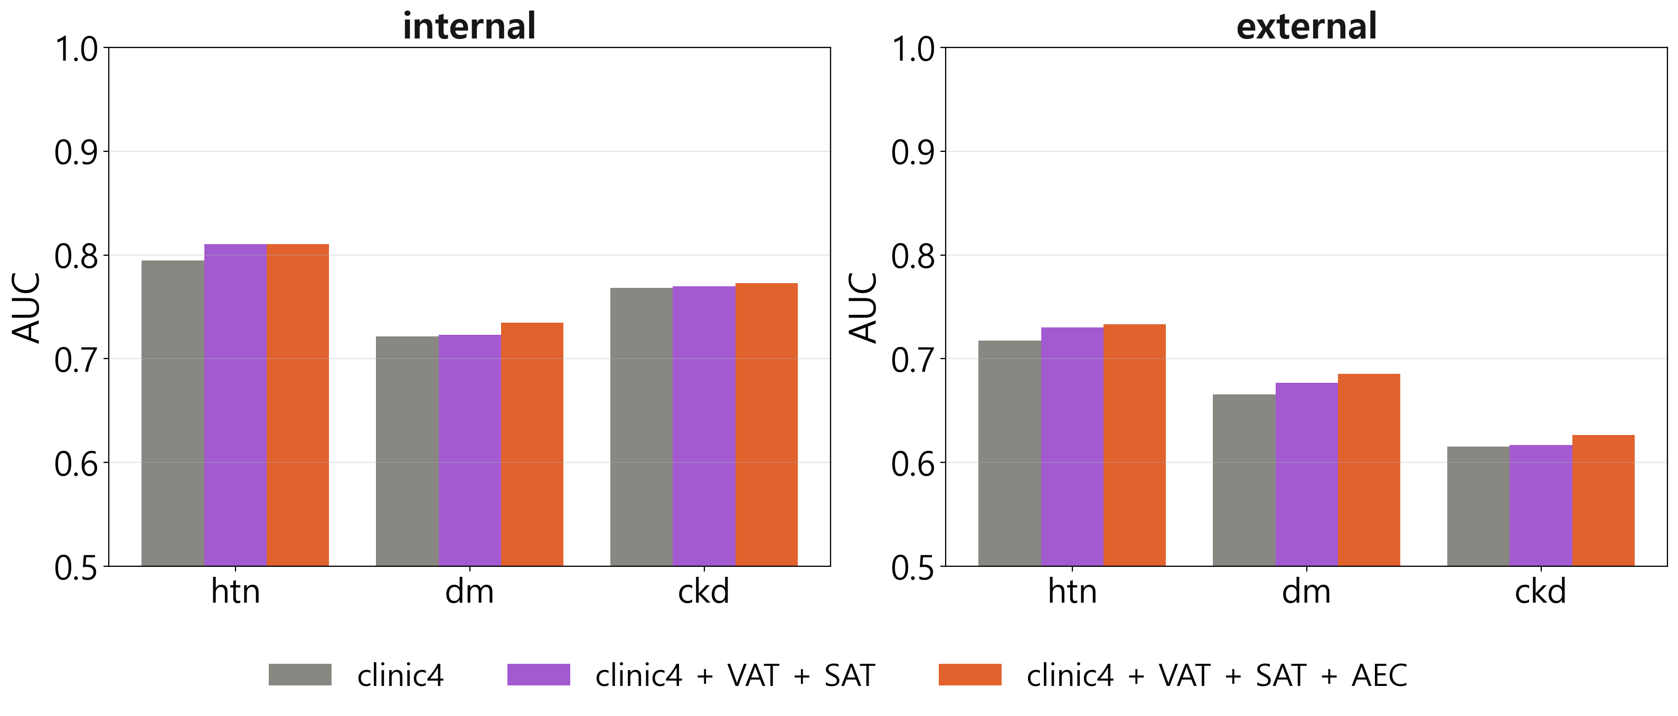Figure 4. Internal (left) and external (right) AUC for the three-step Family B nested model (clinic4 → clinic4+VAT+SAT → clinic4+VAT+SAT+AEC) for hypertension (HTN), diabetes mellitus (DM), and chronic kidney disease (CKD).
At the internal out-of-fold Youden-optimal threshold, applied unchanged to the external cohort (Table S3), adding the AEC score raised sensitivity in 11 of 12 comparisons (median +5.2 percentage points) at the cost of specificity, and lowered overall accuracy in 10 of 12 comparisons; the largest shift was for chronic kidney disease (external, Family A), where sensitivity rose from 46.8% to 68.6% while specificity fell from 66.7% to 47.8%, and accuracy fell from 63.4% to 51.3% (−12.1 percentage points) — driven by the outcome's low external prevalence (16.7%).

Calibration
Model calibration (Figure 5; full results in Table S4) was good in the internal cohort for every model and outcome (calibration slope, 0.93–0.99; intercept, −0.12 to −0.01), consistent with the internal OOF design. Calibration was substantially weaker in the external cohort (slope, 0.40–0.84), indicating that predicted probabilities systematically overstated between-patient risk separation relative to observed outcome frequency once the frozen internal model was applied externally; this attenuation was most pronounced for chronic kidney disease (external slope, 0.40–0.49 across models), the outcome with the largest between-cohort prevalence shift (8.3% internal vs 16.7% external). Brier scores were correspondingly higher externally than internally for every outcome (e.g., chronic kidney disease, 0.138–0.141 external vs 0.070–0.071 internal). Adding the AEC score did not meaningfully change calibration relative to its corresponding baseline model in either cohort.
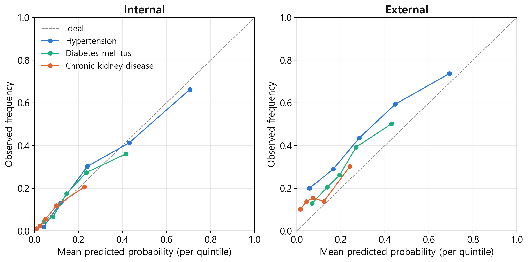Figure 5. Calibration (reliability) plots for the fullest model (clinic4+VAT+SAT+AEC), internal (left) and external (right), for hypertension (HTN), diabetes mellitus (DM), and chronic kidney disease (CKD). Points show the mean predicted probability and observed outcome frequency within each quintile of predicted risk; the dashed line indicates perfect calibration.

Robustness and Ancillary Analyses
Continuous NRI and IDI for the AEC increment were mostly positive (10 of 12 combinations), with the largest internal gains for hypertension, diabetes, and chronic kidney disease (NRI 0.31–0.34) and one sign reversal externally (hypertension, VAT+SAT family; Table S5).
AUC for the fullest model was broadly consistent across the three scanner vendors with adequate sample size in each cohort (internal 0.675–0.835; external 0.597–0.748), without any vendor reversing the pooled-cohort direction; the small residual ‘Other’ vendor subgroup (external n=24) was comparatively unstable, as expected given its size (Table S6).
Redundancy with Known Predictors.—Mean_mAs correlated with VAT and SAT to a similar degree as the AEC components did (internal: r=0.43 with VAT, r=0.35 with SAT; external: r=0.27 with VAT, r=0.27 with SAT), indicating that the two baseline families (mean_mAs vs VAT+SAT) are not measuring fully independent information either. To test whether the AEC-outcome correlations reported above reflect a signal independent of age, sex, height, weight, VAT, and SAT, each AEC component was regressed on these six covariates and its residual was correlated with each outcome (Figure 6; Table S7). Most raw AEC component-outcome correlations (|r|=0.01–0.34; 13 of 18 P<.05) attenuated to non-significance after this adjustment (|r|≤0.05, P≥.08); notably, the second principal component's largest raw correlation—with hypertension (internal r=−0.34, external r=−0.18)—fully attenuated in both cohorts (internal P=.078, external P=.175), consistent with much of the raw association reflecting shared demographic/adiposity information rather than an independent curve-shape signal. Two residual associations survived adjustment, both for the second principal component: with diabetes in the internal cohort only (partial r=−0.095, P<.001; external P=.077) and with chronic kidney disease in the external cohort only (partial r=−0.103, P<.001; internal P=.113); neither replicated in the other cohort for the same outcome. Both survived Benjamini-Hochberg correction across the 18 component-outcome tests (q=.007 each), so they are unlikely to reflect false discovery from testing 18 associations, but the lack of within-outcome cross-cohort replication is a more important source of caution than the multiple-testing question alone. Variance inflation factors for the combined design matrix (age, height, weight, VAT, SAT, FPCA PC1–3) ranged from 1.3 to 3.3, below the conventional threshold of 5, indicating multicollinearity was not a material concern for the coefficient estimates themselves.
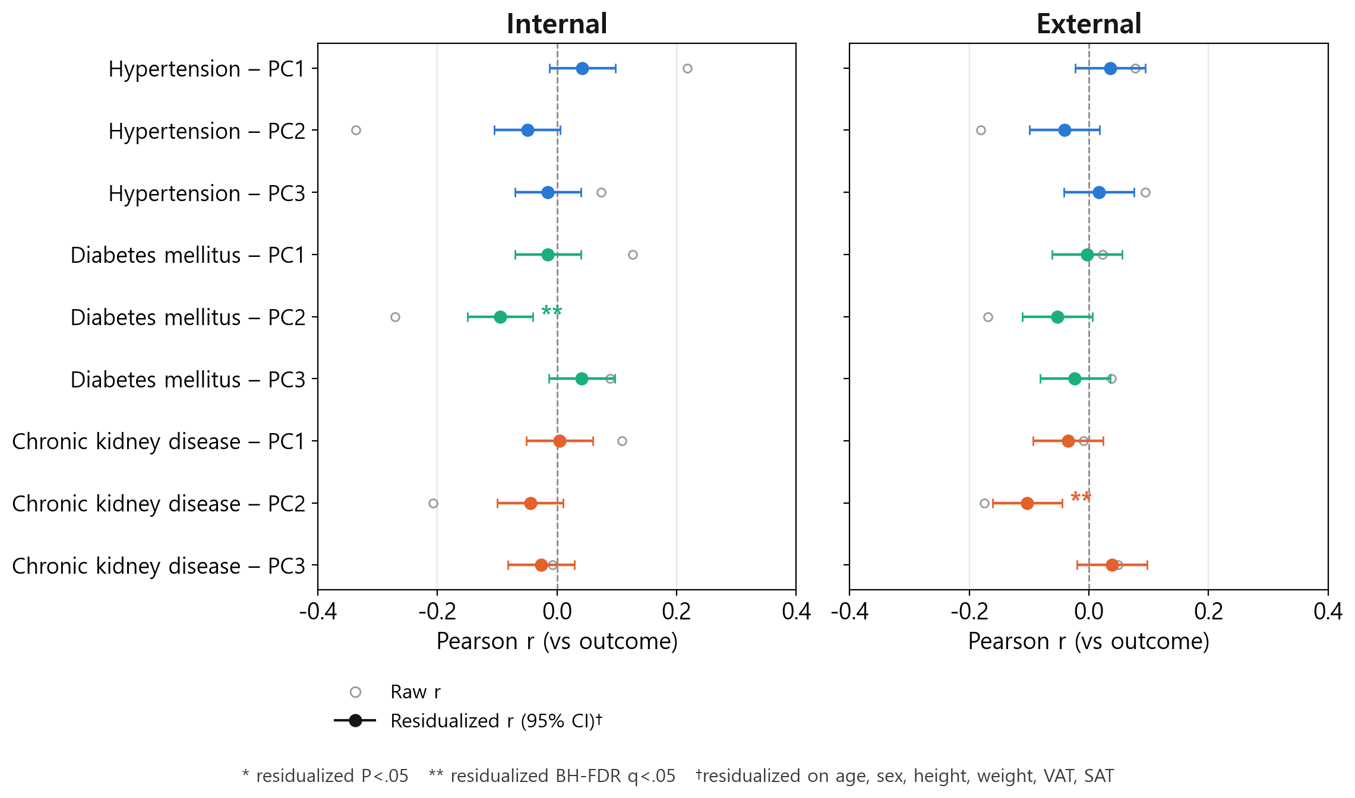Figure 6. Forest plot of Pearson correlations between each AEC functional principal component (FPCA PC1–3) and each outcome—hypertension (HTN), diabetes mellitus (DM), and chronic kidney disease (CKD)—before (raw, open circles) and after (residualized, filled circles with 95% CI) adjusting the component for age, sex, height, weight, VAT, and SAT, in the internal (left) and external (right) cohorts. Residualized 95% CIs were derived by the Fisher z transformation. *residualized P<.05; **residualized Benjamini-Hochberg FDR q<.05. Full numeric values, including raw P and BH-FDR q for all 18 tests, are in Table S7.

Discussion
To our knowledge, this is the first study to directly examine whether the AEC tube current modulation curve—recorded on essentially every clinically indicated CT scan but studied previously only as a radiation-dose signal—carries information about a patient's cardiometabolic disease status. Adding a fixed, three-component AEC shape score on top of a demographic baseline (clinic4) plus either scan-technique (mean_mAs) or CT-derived fat-depot (VAT+SAT) information increased AUC in 11 of 12 outcome-cohort-family comparisons (median ΔAUC=+0.009), with three nominally significant increments—all within the family lacking CT-adiposity information—for hypertension (external, P=.020), diabetes (internal, P=.012), and chronic kidney disease (external, P=.007). None of these 24 prespecified DeLong comparisons survived Bonferroni correction, and none reached significance under a Benjamini-Hochberg FDR sensitivity analysis (minimum q=.084). In a separate, exploratory partial-correlation analysis of the 18 component-outcome pairs, corrected independently of the DeLong tests, adjusting each AEC component for age, sex, height, weight, and CT-derived fat area attenuated most associations to non-significance; a residual association survived Benjamini-Hochberg correction only for the second principal component, with diabetes internally (partial r=−0.095, 95% CI −0.149 to −0.040) and chronic kidney disease externally (partial r=−0.103, 95% CI −0.161 to −0.045)—neither replicating in the other cohort for the same outcome. Because these two analyses test related but distinct hypotheses and were corrected separately rather than jointly, we regard the residual PC2 association as a hypothesis-generating observation rather than a confirmed independent effect, particularly given its lack of cross-cohort replication.
The mechanistic rationale for testing the AEC curve at all is that z-axis tube current is servo-controlled to the patient's own cross-sectional attenuation (4,5), so the resulting curve should, in principle, encode body habitus and its regional distribution—the same property that underlies CT-derived VAT/SAT and other opportunistic biomarkers of cardiometabolic risk (6–10). However, AEC-modulated tube current at a given z-position is also shaped by factors unrelated to body composition, including intravenous contrast phase and timing, patient centering within the gantry, and scanner-specific target noise index, reconstruction algorithm, and pitch; none of these were recorded in the clinical database available for this study and so could not be adjusted for or examined in a sensitivity analysis. A concrete illustration of this non-anatomic sensitivity is that mean tube current differed substantially between our two cohorts (312.5±85.9 mA internal vs 204.1±84.1 mA external, P<.001) despite nearly identical height and weight (Table 1); if the same site-level protocol differences that produce this 35% gap in absolute tube current also shift the distribution of the FPCA shape components, they would be expected to degrade calibration when a model fit internally is applied externally without recalibration—consistent with the external calibration slopes of 0.40–0.84 reported below (Table S4), though we could not test this mechanism directly without the acquisition-parameter data described above. Prior work has shown CT radiomic texture features can be markedly unstable across tube-current levels (21); our vendor-subgroup AUC was broadly consistent despite this (Table S6), but cross-hardware sensitivity remains an important caveat for multi-vendor deployment. Directly testing whether the AEC score instead reflects information already captured by routinely available covariates, adjusting each AEC component for age, sex, height, weight, VAT, and SAT attenuated most raw component-outcome correlations to non-significance (Table S7); mean_mAs itself correlated with VAT and SAT to a similar degree as the AEC components did (r=0.27–0.43), so the two baseline families are themselves not fully independent of one another. The exception, as noted above, was the second principal component's residual association with diabetes (internal only) and chronic kidney disease (external only); although each survived Benjamini-Hochberg correction across the 18 component-outcome tests (q=.007), the absence of within-outcome cross-cohort replication is a more consequential caveat than the multiple-testing question, since such replication is the strongest form of evidence this two-cohort design can offer.
Practically, the AEC-128 curve requires no additional radiation, acquisition time, reconstruction, or manual segmentation beyond what most clinically indicated CT protocols already log—unlike VAT and SAT, which require a dedicated body-composition segmentation pipeline (12); a signal already present in the scanner's exposure log costs nothing to compute, so continued evaluation of its incremental value, particularly the residual PC2 association noted above, may still be worthwhile as a zero-cost adjunct to opportunistic CT screening pipelines (1–3,9,10). Our two-hospital internal-development/external-validation design and paired DeLong testing follow the template of a recent study adding a spirometry curve-derived score to a clinical model for predicting COPD exacerbation (20); as in that study, the curve-derived score improved discrimination in both cohorts, though unlike that study none of our comparisons survived multiplicity correction, and the AEC curve sits mechanistically further from the outcome (tube current → attenuation → body composition → risk) than a direct physiological measurement like spirometry—so we intend this as a methodological template rather than a claim of comparable evidentiary strength. We also used a small, prespecified, clinically interpretable functional-PCA representation—fixed before any outcome-specific model selection (13–16), rather than a deep-learning encoding of the raw curve—trading some discriminative ceiling for a lower risk of overfitting in a modestly sized, class-imbalanced cohort (as few as 105 chronic-kidney-disease-positive patients internally); however, because we did not characterize which curve-shape feature each principal component represents (e.g., via its eigenfunction/loading curve), the residual PC2 association cannot yet be linked to a specific, interpretable feature of curve shape—an important target for future work alongside acquisition-parameter data.
Several limitations should be considered when interpreting these results. First, because the classification threshold was fixed at the internal out-of-fold Youden index and applied unchanged to the external cohort, adding the AEC score shifted the operating point toward higher sensitivity at the cost of specificity in 11 of 12 comparisons, lowering overall accuracy in 10 of 12—most sharply for chronic kidney disease (external, mean_mAs family: 63.4%→51.3%)—and external calibration was weaker than internal for every outcome (most markedly chronic kidney disease; Table S4); any future application of this or a similar model at a new site should therefore include site-specific recalibration rather than applying the raw predicted probabilities reported here. Second, hypertension, diabetes, and chronic kidney disease labels reflected ever-diagnosed status from cumulative ICD-10 history rather than a diagnosis anchored to the CT acquisition date; this is a more consequential limitation for a study framed around an opportunistic, scan-time biomarker than a single caveat might suggest, since patients diagnosed only after the scan are labeled positive despite not being detectably diseased at scan time, while undiagnosed disease at scan time—precisely the population an opportunistic tool would most need to detect—is labeled negative. We did not have laboratory-based case definitions (e.g., estimated glomerular filtration rate for chronic kidney disease) to perform a sensitivity analysis; chronic kidney disease, with the lowest AUC and smallest positive count in both cohorts, is likely most affected. Third, the internal and external cohorts were drawn from two tertiary-care hospitals within a single healthcare system in one country; chronic-kidney-disease-positive samples (n=105 internal, n=188 external) were modest for subgroup analyses such as the vendor-stratified comparison (Table S6); we did not have a third, fully independent cohort; and the mean_mAs and VAT+SAT baseline predictor sets were themselves correlated with each other and with the AEC score, so this study cannot fully disentangle scan-technique, CT-adiposity, and curve-shape information from one another. Finally, this was a retrospective study without a priori sample-size or power calculation; internal cross-validation used 5 folds throughout, since the smallest outcome-cohort combination (chronic kidney disease, internal, n=105 positive) still exceeded the minimum-count threshold for a full 5-fold split; and all statistical and computational analyses were performed by a single author, an added reproducibility caveat given that most of the reported associations did not reach significance after correction.
In summary, the AEC-128 tube current modulation curve—an opportunistic, cost-free byproduct of virtually every clinically acquired CT scan—showed a small, directionally consistent association with hypertension, diabetes, and chronic kidney disease beyond age, sex, height, weight, and CT-derived visceral and subcutaneous fat area, but this association did not reach statistical significance after correction for multiple comparisons and was, for most of its components, substantially explained by these same covariates. A residual association in one component that survived adjustment is worth further investigation, but the present results do not support the AEC score as a validated, standalone cardiometabolic biomarker. Larger, multi-institutional, prospectively designed validation—ideally with scan-time-anchored outcomes, acquisition-parameter data (contrast phase, reconstruction kernel, pitch), and a wider range of scanner vendors and protocols—will be needed before its clinical value, if any, can be established.

Data Availability.—[PLACEHOLDER] The datasets analyzed in this study are not publicly available due to institutional data-sharing restrictions on identifiable clinical imaging data, but de-identified data may be available from the corresponding author upon reasonable request and with institutional approval. [Confirm actual data-sharing policy before submission.]
Code Availability.—[PLACEHOLDER] The analysis code used in this study is available from the corresponding author upon request. [Confirm whether code will be deposited in a public repository before submission.]
Author Contributions.—[PLACEHOLDER: insert full author list, degrees, affiliations, and a contribution statement (e.g., conceptualization, data curation, formal analysis, writing) before submission.]
Conflicts of Interest.—[PLACEHOLDER: insert authors' disclosures, or “The authors declare no conflicts of interest,” before submission.]
Funding.—[PLACEHOLDER: insert funding source(s), or state that this research received no specific grant from any funding agency, before submission.]
Study Registration.—Not applicable; this was a retrospective, non-interventional study.
Generative AI Use.—[PLACEHOLDER: state whether and how generative AI tools were used in manuscript preparation or analysis, per the target journal's current author instructions.]

References
1. Chang Y, Yoon SH, Kwon R, et al. Automated Comprehensive CT Assessment of the Risk of Diabetes and Associated Cardiometabolic Conditions. Radiology 2024;312(2):e233410.
2. Pickhardt PJ. Value-added Opportunistic CT Screening: State of the Art. Radiology 2022;303(2):241-254.
3. Pickhardt PJ, Summers RM, Garrett JW, et al. Opportunistic Screening: Radiology Scientific Expert Panel. Radiology 2023;307(5):e222044.
4. Kalra MK, Maher MM, Toth TL, et al. Comparison of Z-axis automatic tube current modulation technique with fixed tube current CT scanning of abdomen and pelvis. Radiology 2004;232:347-353.
5. McCollough CH, Bruesewitz MR, Kofler JM Jr. CT dose reduction and dose management tools: overview of available options. RadioGraphics 2006;26(2):503-512.
6. Bostani M, McMillan K, Lu P, Kim HJ, Cagnon CH, DeMarco JJ, McNitt-Gray MF. Attenuation-based size metric for estimating organ dose to patients undergoing tube current modulated CT exams. Med Phys 2015;42(2):958-968.
7. Boone JM, Strauss KJ, Cody DD, et al. Size-Specific Dose Estimates (SSDE) in Pediatric and Adult Body CT Examinations. AAPM Report No. 204. American Association of Physicists in Medicine; 2011.
8. Li X, Marschall TA, Yang K, Liu B. Technical note: Advancing size-specific dose estimates in CT examinations: Dose estimates at longitudinal positions of scans. Med Phys 2022;49(2):1303-1311.
9. Pickhardt PJ, Graffy PM, Zea R, et al. Utilizing Fully Automated Abdominal CT-Based Biomarkers for Opportunistic Screening for Metabolic Syndrome in Adults Without Symptoms. AJR Am J Roentgenol 2021;216(1):85-92.
10. Chung GE, Yoon JW, Kim H, Han YM, Choi SY, Heo NJ. Association between visceral adipose tissue measured by deep neural network architecture and chronic kidney disease. Sci Rep 2026;16(1):9587.
11. Medrano MJ, et al. Scout-Dose-TCM: Direct and Prospective Scout-Based Estimation of Personalized Organ Doses from Tube Current Modulated CT Exams. arXiv:2506.24062, 2025.
12. Wasserthal J, Breit HC, Meyer MT, et al. TotalSegmentator: Robust Segmentation of 104 Anatomic Structures in CT Images. Radiol Artif Intell 2023;5(5):e230024.
13. Ramsay JO, Silverman BW. Functional Data Analysis. 2nd ed. Springer; 2005.
14. Shi B, Wei P, Huang X. Functional principal component based landmark analysis for the effects of longitudinal cholesterol profiles on the risk of coronary heart disease. Stat Med 2021;40(3):650-667.
15. Jiang S, Cao J, Rosner B, Colditz GA. Supervised two-dimensional functional principal component analysis with time-to-event outcomes and mammogram imaging data. Biometrics 2023;79(2):1359-1369.
16. Satopaa V, Albrecht J, Irwin D, Raghavan B. Finding a "Kneedle" in a Haystack: Detecting Knee Points in System Behavior. Proc 31st Int Conf Distrib Comput Syst Workshops (ICDCSW) 2011:166-171.
17. DeLong ER, DeLong DM, Clarke-Pearson DL. Comparing the areas under two or more correlated receiver operating characteristic curves: a nonparametric approach. Biometrics 1988;44(3):837-845.
18. Sun X, Xu W. Fast Implementation of DeLong's Algorithm for Comparing the Areas Under Correlated Receiver Operating Characteristic Curves. IEEE Signal Process Lett 2014;21(11):1389-1393.
19. Youden WJ. Index for rating diagnostic tests. Cancer 1950;3(1):32-35.
20. Jeon ET, Park H, Lee JK, Heo EY, Lee CH, Kim DK, Kim DH, Lee HW. Deep Learning-Based Chronic Obstructive Pulmonary Disease Exacerbation Prediction Using Flow-Volume and Volume-Time Curve Imaging: Retrospective Cohort Study. J Med Internet Res 2025;27:e69785.
21. Bartholomeus GA, van Amsterdam WAC, den Harder AM, Willemink MJ, van Hamersvelt RW, de Jong PA, Leiner T. Robustness of pulmonary nodule radiomic features on computed tomography as a function of varying radiation dose levels—a multi-dose in vivo patient study. Eur Radiol 2023;33(10):7044-7055.
22. Pepe MS, Janes H, Li CI. Net risk reclassification p values: valid or misleading? J Natl Cancer Inst. 2014;106(4):dju041.
23. Kerr KF, Wang Z, Janes H, McClelland RL, Psaty BM, Pepe MS. Net reclassification indices for evaluating risk prediction instruments: a critical review. Epidemiology. 2014;25(1):114-121.
24. Collins GS, Reitsma JB, Altman DG, Moons KGM. Transparent Reporting of a Multivariable Prediction Model for Individual Prognosis or Diagnosis (TRIPOD): The TRIPOD Statement. Ann Intern Med. 2015;162(1):55-63.

Appendix S1. Detailed Patient Selection Criteria
Examinations were sequentially excluded from each cohort as follows, matching the order and per-criterion counts shown in Figure 1: (1) missing height or weight in the clinical database; (2) age younger than 20 years at the time of the CT examination; (3) height, weight, or BMI identified as an outlier by the interquartile-range (IQR) rule, applied independently to each variable within each cohort (values below Q1−1.5×IQR or above Q3+1.5×IQR); (4) missing values for any other clinical variable used in the analysis (age, sex, height, weight, VAT, SAT, mean_mAs, or outcome status); and (5) AEC signal curve-validity criteria: the cropped pubis-liver AEC-128 curve was excluded if its coefficient of variation was below 0.05, its range (maximum minus minimum tube current) was below 10 mA, or its correlation with a linear trend exceeded R²=0.95 (i.e., an implausibly flat, low-variability, or near-perfectly monotonic curve, each indicating a likely invalid or non-physiological signal rather than genuine AEC modulation).

Appendix S2. Supplementary Tables
Table S1. Internal (out-of-fold) and external (frozen-model) AUC for the three-step nested logistic regression models, by outcome, cohort, and model family, with paired DeLong P values for each incremental step. Family A adds mean_mAs and then the AEC score; Family B adds VAT+SAT and then the AEC score.
Outcome | Cohort | Family | AUC clinic4 | AUC +covariate | AUC +covariate+AEC | DeLong P (+covariate) | DeLong P (+AEC)
Hypertension | Internal | A: +mean mAs | 0.794 | 0.796 | 0.802 | 0.454 | 0.156
 |  | B: +VAT+SAT | 0.794 | 0.811 | 0.81 | 0.005 | 0.912
 | External | A: +mean mAs | 0.718 | 0.718 | 0.73 | 0.835 | 0.02
 |  | B: +VAT+SAT | 0.718 | 0.73 | 0.733 | 0.086 | 0.261
Diabetes mellitus | Internal | A: +mean mAs | 0.722 | 0.721 | 0.741 | 0.073 | 0.012
 |  | B: +VAT+SAT | 0.722 | 0.723 | 0.735 | 0.82 | 0.05
 | External | A: +mean mAs | 0.665 | 0.665 | 0.681 | 0.953 | 0.07
 |  | B: +VAT+SAT | 0.665 | 0.677 | 0.686 | 0.112 | 0.181
Chronic kidney disease | Internal | A: +mean mAs | 0.768 | 0.768 | 0.772 | 0.787 | 0.592
 |  | B: +VAT+SAT | 0.768 | 0.77 | 0.773 | 0.782 | 0.657
 | External | A: +mean mAs | 0.616 | 0.614 | 0.63 | 0.359 | 0.007
 |  | B: +VAT+SAT | 0.616 | 0.617 | 0.626 | 0.787 | 0.079

Table S2. Benjamini-Hochberg false discovery rate (FDR) q-values for the 24 paired DeLong tests, reported as a sensitivity analysis alongside the Bonferroni-corrected threshold (α=.05/24=.0021) used in the primary analysis.
Outcome | Cohort | Comparison | AUC diff | DeLong P | BH-FDR q
Hypertension | External | clinic4 -> clinic4 + mean mAs | 0.0007 | 0.835 | 0.911
 |  | clinic4 -> clinic4 + VAT + SAT | 0.0123 | 0.086 | 0.231
 |  | clinic4 + mean mAs -> clinic4 + mean mAs + AEC | 0.0113 | 0.02 | 0.118
 |  | clinic4 + VAT + SAT -> clinic4 + VAT + SAT + AEC | 0.0035 | 0.261 | 0.481
 | Internal | clinic4 -> clinic4 + mean mAs | 0.0019 | 0.454 | 0.726
 |  | clinic4 -> clinic4 + VAT + SAT | 0.0161 | 0.005 | 0.084
 |  | clinic4 + mean mAs -> clinic4 + mean mAs + AEC | 0.0059 | 0.156 | 0.341
 |  | clinic4 + VAT + SAT -> clinic4 + VAT + SAT + AEC | -0.0003 | 0.912 | 0.952
Diabetes mellitus | External | clinic4 -> clinic4 + mean mAs | -0.0 | 0.953 | 0.953
 |  | clinic4 -> clinic4 + VAT + SAT | 0.0114 | 0.112 | 0.269
 |  | clinic4 + mean mAs -> clinic4 + mean mAs + AEC | 0.0157 | 0.07 | 0.231
 |  | clinic4 + VAT + SAT -> clinic4 + VAT + SAT + AEC | 0.0087 | 0.181 | 0.363
 | Internal | clinic4 -> clinic4 + mean mAs | -0.001 | 0.073 | 0.231
 |  | clinic4 -> clinic4 + VAT + SAT | 0.0014 | 0.82 | 0.911
 |  | clinic4 + mean mAs -> clinic4 + mean mAs + AEC | 0.0199 | 0.012 | 0.093
 |  | clinic4 + VAT + SAT -> clinic4 + VAT + SAT + AEC | 0.0117 | 0.05 | 0.231
Chronic kidney disease | External | clinic4 -> clinic4 + mean mAs | -0.0015 | 0.359 | 0.616
 |  | clinic4 -> clinic4 + VAT + SAT | 0.0014 | 0.787 | 0.911
 |  | clinic4 + mean mAs -> clinic4 + mean mAs + AEC | 0.0156 | 0.007 | 0.084
 |  | clinic4 + VAT + SAT -> clinic4 + VAT + SAT + AEC | 0.0095 | 0.079 | 0.231
 | Internal | clinic4 -> clinic4 + mean mAs | -0.0005 | 0.787 | 0.911
 |  | clinic4 -> clinic4 + VAT + SAT | 0.0016 | 0.782 | 0.911
 |  | clinic4 + mean mAs -> clinic4 + mean mAs + AEC | 0.0039 | 0.592 | 0.888
 |  | clinic4 + VAT + SAT -> clinic4 + VAT + SAT + AEC | 0.0031 | 0.657 | 0.911

Table S3. Sensitivity, specificity, and accuracy at the internal out-of-fold (OOF) cross-validation threshold maximizing the Youden index (sensitivity + specificity − 1), applied unchanged to the external cohort.
Outcome | Model | Cohort | n (n_pos) | AUC | Sensitivity | Specificity | Accuracy
Hypertension | clinic4 | Internal | 1259 (385) | 0.795 | 81.6% | 65.1% | 70.1%
 |  | External | 1123 (507) | 0.718 | 78.1% | 55.5% | 65.7%
 | clinic4 + mean mAs | Internal | 1259 (385) | 0.796 | 70.6% | 75.6% | 74.1%
 |  | External | 1123 (507) | 0.718 | 55.8% | 75.5% | 66.6%
 | clinic4 + mean mAs + AEC | Internal | 1259 (385) | 0.802 | 73.8% | 72.0% | 72.5%
 |  | External | 1123 (507) | 0.73 | 61.1% | 71.8% | 67.0%
 | clinic4 + VAT + SAT | Internal | 1259 (385) | 0.811 | 83.9% | 65.0% | 70.8%
 |  | External | 1123 (507) | 0.73 | 78.5% | 56.0% | 66.2%
 | clinic4 + VAT + SAT + AEC | Internal | 1259 (385) | 0.81 | 87.3% | 59.6% | 68.1%
 |  | External | 1123 (507) | 0.733 | 80.1% | 51.3% | 64.3%
Diabetes mellitus | clinic4 | Internal | 1259 (232) | 0.722 | 83.2% | 52.8% | 58.4%
 |  | External | 1123 (335) | 0.665 | 76.7% | 43.8% | 53.6%
 | clinic4 + mean mAs | Internal | 1259 (232) | 0.721 | 78.4% | 58.4% | 62.1%
 |  | External | 1123 (335) | 0.665 | 72.5% | 51.0% | 57.4%
 | clinic4 + mean mAs + AEC | Internal | 1259 (232) | 0.741 | 83.6% | 54.4% | 59.8%
 |  | External | 1123 (335) | 0.681 | 83.9% | 36.0% | 50.3%
 | clinic4 + VAT + SAT | Internal | 1259 (232) | 0.723 | 78.9% | 57.3% | 61.2%
 |  | External | 1123 (335) | 0.677 | 74.9% | 49.6% | 57.2%
 | clinic4 + VAT + SAT + AEC | Internal | 1259 (232) | 0.735 | 77.6% | 59.6% | 62.9%
 |  | External | 1123 (335) | 0.686 | 80.0% | 43.0% | 54.1%
Chronic kidney disease | clinic4 | Internal | 1259 (105) | 0.768 | 81.9% | 61.7% | 63.4%
 |  | External | 1123 (188) | 0.616 | 66.5% | 51.0% | 53.6%
 | clinic4 + mean mAs | Internal | 1259 (105) | 0.768 | 72.4% | 71.1% | 71.2%
 |  | External | 1123 (188) | 0.614 | 46.8% | 66.7% | 63.4%
 | clinic4 + mean mAs + AEC | Internal | 1259 (105) | 0.772 | 84.8% | 59.6% | 61.7%
 |  | External | 1123 (188) | 0.63 | 68.6% | 47.8% | 51.3%
 | clinic4 + VAT + SAT | Internal | 1259 (105) | 0.77 | 79.0% | 66.6% | 67.7%
 |  | External | 1123 (188) | 0.617 | 58.5% | 56.8% | 57.1%
 | clinic4 + VAT + SAT + AEC | Internal | 1259 (105) | 0.773 | 81.9% | 62.0% | 63.6%
 |  | External | 1123 (188) | 0.627 | 67.6% | 47.8% | 51.1%

Table S4. Calibration slope, intercept, and Brier score for all model/outcome/cohort combinations, computed from out-of-fold (internal) or frozen-model (external) predicted probabilities.
Outcome | Model | Cohort | Calibration slope | Calibration intercept | Brier score
Hypertension | clinic4 | Internal | 0.984 | -0.014 | 0.165
 |  | External | 0.676 | 0.324 | 0.225
 | clinic4 + mean mAs | Internal | 0.978 | -0.019 | 0.165
 |  | External | 0.683 | 0.534 | 0.238
 | clinic4 + mean mAs + AEC | Internal | 0.956 | -0.035 | 0.162
 |  | External | 0.766 | 0.55 | 0.23
 | clinic4 + VAT + SAT | Internal | 0.969 | -0.024 | 0.159
 |  | External | 0.656 | 0.307 | 0.222
 | clinic4 + VAT + SAT + AEC | Internal | 0.947 | -0.044 | 0.159
 |  | External | 0.698 | 0.437 | 0.225
Diabetes mellitus | clinic4 | Internal | 0.986 | -0.022 | 0.136
 |  | External | 0.743 | 0.229 | 0.204
 | clinic4 + mean mAs | Internal | 0.984 | -0.023 | 0.136
 |  | External | 0.744 | 0.236 | 0.205
 | clinic4 + mean mAs + AEC | Internal | 0.975 | -0.036 | 0.133
 |  | External | 0.842 | 0.292 | 0.2
 | clinic4 + VAT + SAT | Internal | 0.936 | -0.092 | 0.135
 |  | External | 0.743 | 0.229 | 0.203
 | clinic4 + VAT + SAT + AEC | Internal | 0.933 | -0.094 | 0.133
 |  | External | 0.82 | 0.236 | 0.198
Chronic kidney disease | clinic4 | Internal | 0.968 | -0.065 | 0.071
 |  | External | 0.404 | -0.602 | 0.14
 | clinic4 + mean mAs | Internal | 0.961 | -0.079 | 0.071
 |  | External | 0.402 | -0.568 | 0.141
 | clinic4 + mean mAs + AEC | Internal | 0.94 | -0.121 | 0.07
 |  | External | 0.492 | -0.386 | 0.139
 | clinic4 + VAT + SAT | Internal | 0.961 | -0.07 | 0.07
 |  | External | 0.424 | -0.553 | 0.139
 | clinic4 + VAT + SAT + AEC | Internal | 0.938 | -0.117 | 0.07
 |  | External | 0.48 | -0.442 | 0.138

Table S5. Continuous net reclassification improvement (NRI) and integrated discrimination improvement (IDI) for adding the AEC score on top of each covariate step (mean_mAs or VAT+SAT).
Outcome | Cohort | Family | Continuous NRI | IDI
Hypertension | Internal | A: +mean mAs -> +AEC | 0.344 | 0.0163
 |  | B: +VAT+SAT -> +AEC | 0.184 | 0.0049
 | External | A: +mean mAs -> +AEC | 0.078 | 0.0084
 |  | B: +VAT+SAT -> +AEC | -0.062 | -0.0069
Diabetes mellitus | Internal | A: +mean mAs -> +AEC | 0.33 | 0.0245
 |  | B: +VAT+SAT -> +AEC | 0.221 | 0.0113
 | External | A: +mean mAs -> +AEC | -0.015 | 0.0066
 |  | B: +VAT+SAT -> +AEC | 0.011 | 0.003
Chronic kidney disease | Internal | A: +mean mAs -> +AEC | 0.249 | 0.0068
 |  | B: +VAT+SAT -> +AEC | 0.308 | 0.0055
 | External | A: +mean mAs -> +AEC | 0.193 | 0.0078
 |  | B: +VAT+SAT -> +AEC | 0.087 | 0.0045

Table S6. AUC by scanner-vendor subgroup for the fullest model (clinic4+VAT+SAT+AEC), without vendor-specific re-training. NR† indicates a subgroup with fewer than 5 outcome-positive patients, for which a point AUC estimate is not reportable given its instability.
Outcome | Cohort | Vendor | n (n_pos) | AUC
Hypertension | Internal | Siemens | 688 (249) | 0.817
 |  | GE | 329 (57) | 0.831
 |  | Philips | 236 (78) | 0.749
 |  | Other | 6 (1) | NR†
 | External | Siemens | 653 (290) | 0.729
 |  | GE | 217 (109) | 0.748
 |  | Philips | 228 (94) | 0.733
 |  | Other | 24 (14) | 0.657
Diabetes mellitus | Internal | Siemens | 688 (138) | 0.744
 |  | GE | 329 (48) | 0.732
 |  | Philips | 236 (46) | 0.699
 | External | Siemens | 653 (187) | 0.666
 |  | GE | 217 (69) | 0.728
 |  | Philips | 228 (73) | 0.720
 |  | Other | 24 (6) | 0.630
Chronic kidney disease | Internal | Siemens | 688 (74) | 0.765
 |  | GE | 329 (13) | 0.835
 |  | Philips | 236 (18) | 0.675
 | External | Siemens | 653 (109) | 0.597
 |  | GE | 217 (49) | 0.634
 |  | Philips | 228 (29) | 0.744
 |  | Other | 24 (1) | NR†

Table S7. Pearson correlation between each AEC functional principal component (FPCA PC1–3) and each outcome, before (raw) and after (residualized) adjusting the component for age, sex, height, weight, VAT, and SAT. Residualized 95% CI was derived by the Fisher z transformation. Residualized BH-FDR q is the Benjamini-Hochberg-adjusted P value across these 18 tests. Residualized r is the correlation between the outcome and the component's residual from a linear regression on these six covariates.
Outcome | Cohort | AEC component | Raw r  (vs outcome) | Raw P | Residualized r* | Residualized 95% CI | Residualized P | Residualized BH-FDR q
Hypertension | External | PC1 | 0.078 | 0.009 | 0.036 | -0.023 to 0.094 | 0.225 | 0.406
 |  | PC2 | -0.181 | <0.001 | -0.041 | -0.099 to 0.018 | 0.175 | 0.388
 |  | PC3 | 0.094 | 0.002 | 0.017 | -0.042 to 0.075 | 0.572 | 0.669
 | Internal | PC1 | 0.218 | <0.001 | 0.042 | -0.013 to 0.097 | 0.132 | 0.36
 |  | PC2 | -0.336 | <0.001 | -0.05 | -0.105 to 0.005 | 0.078 | 0.351
 |  | PC3 | 0.074 | 0.009 | -0.015 | -0.070 to 0.040 | 0.593 | 0.669
Diabetes mellitus | External | PC1 | 0.022 | 0.454 | -0.003 | -0.061 to 0.056 | 0.920 | 0.92
 |  | PC2 | -0.168 | <0.001 | -0.053 | -0.111 to 0.006 | 0.077 | 0.351
 |  | PC3 | 0.037 | 0.210 | -0.023 | -0.081 to 0.036 | 0.434 | 0.601
 | Internal | PC1 | 0.127 | <0.001 | -0.015 | -0.070 to 0.040 | 0.595 | 0.669
 |  | PC2 | -0.271 | <0.001 | -0.095 | -0.149 to -0.040 | <0.001 | 0.007
 |  | PC3 | 0.089 | 0.002 | 0.042 | -0.013 to 0.097 | 0.140 | 0.36
Chronic kidney disease | External | PC1 | -0.009 | 0.768 | -0.034 | -0.092 to 0.025 | 0.248 | 0.406
 |  | PC2 | -0.175 | <0.001 | -0.103 | -0.161 to -0.045 | <0.001 | 0.007
 |  | PC3 | 0.049 | 0.104 | 0.039 | -0.020 to 0.097 | 0.194 | 0.388
 | Internal | PC1 | 0.109 | <0.001 | 0.004 | -0.051 to 0.059 | 0.881 | 0.92
 |  | PC2 | -0.207 | <0.001 | -0.045 | -0.100 to 0.010 | 0.113 | 0.36
 |  | PC3 | -0.008 | 0.788 | -0.026 | -0.081 to 0.029 | 0.350 | 0.525

Table S8. Fitted logistic-regression coefficients (log-odds) and odds ratios for the fullest model in each family (clinic4+mean_mAs+AEC, clinic4+VAT+SAT+AEC), for all three outcomes; these are the exact models fit on the entire internal cohort and frozen for external scoring. Continuous predictors (age, height, weight, mean_mAs, VAT, SAT, and each AEC FPCA component) are on the internal-cohort z-score scale described in Predictor Sets and Standardization; sex is coded male=1. These coefficients are provided for transparency and are not intended for direct external point-of-care use without independent validation.
Outcome | Model | Term | Coefficient  (log-odds) | Odds ratio
Hypertension | clinic4 + mean mAs + AEC | Intercept | -1.342 | —
 |  | Sex (male=1) | 0.527 | 1.694
 |  | Age (z-score) | 0.894 | 2.446
 |  | Height (z-score) | -0.183 | 0.833
 |  | Weight (z-score) | 0.262 | 1.300
 |  | mean_mAs (z-score) | 0.164 | 1.178
 |  | AEC FPCA PC1 (z-score) | 0.166 | 1.181
 |  | AEC FPCA PC2 (z-score) | -0.454 | 0.635
 |  | AEC FPCA PC3 (z-score) | 0.045 | 1.046
 | clinic4 + VAT + SAT + AEC | Intercept | -1.391 | —
 |  | Sex (male=1) | 0.632 | 1.882
 |  | Age (z-score) | 0.839 | 2.313
 |  | Height (z-score) | -0.201 | 0.818
 |  | Weight (z-score) | 0.029 | 1.029
 |  | VAT (z-score) | 0.53 | 1.699
 |  | SAT (z-score) | 0.067 | 1.069
 |  | AEC FPCA PC1 (z-score) | 0.209 | 1.232
 |  | AEC FPCA PC2 (z-score) | -0.275 | 0.759
 |  | AEC FPCA PC3 (z-score) | -0.068 | 0.934
Diabetes mellitus | clinic4 + mean mAs + AEC | Intercept | -1.893 | —
 |  | Sex (male=1) | 0.324 | 1.382
 |  | Age (z-score) | 0.398 | 1.489
 |  | Height (z-score) | -0.261 | 0.770
 |  | Weight (z-score) | 0.39 | 1.478
 |  | mean_mAs (z-score) | 0.027 | 1.028
 |  | AEC FPCA PC1 (z-score) | 0.064 | 1.065
 |  | AEC FPCA PC2 (z-score) | -0.494 | 0.610
 |  | AEC FPCA PC3 (z-score) | 0.138 | 1.148
 | clinic4 + VAT + SAT + AEC | Intercept | -1.904 | —
 |  | Sex (male=1) | 0.349 | 1.417
 |  | Age (z-score) | 0.367 | 1.443
 |  | Height (z-score) | -0.267 | 0.766
 |  | Weight (z-score) | 0.297 | 1.346
 |  | VAT (z-score) | 0.207 | 1.230
 |  | SAT (z-score) | 0.031 | 1.032
 |  | AEC FPCA PC1 (z-score) | 0.04 | 1.041
 |  | AEC FPCA PC2 (z-score) | -0.424 | 0.654
 |  | AEC FPCA PC3 (z-score) | 0.093 | 1.097
Chronic kidney disease | clinic4 + mean mAs + AEC | Intercept | -3.247 | —
 |  | Sex (male=1) | 0.826 | 2.284
 |  | Age (z-score) | 0.652 | 1.919
 |  | Height (z-score) | -0.253 | 0.776
 |  | Weight (z-score) | 0.387 | 1.473
 |  | mean_mAs (z-score) | 0.052 | 1.054
 |  | AEC FPCA PC1 (z-score) | 0.065 | 1.067
 |  | AEC FPCA PC2 (z-score) | -0.354 | 0.702
 |  | AEC FPCA PC3 (z-score) | -0.102 | 0.903
 | clinic4 + VAT + SAT + AEC | Intercept | -3.343 | —
 |  | Sex (male=1) | 1.051 | 2.861
 |  | Age (z-score) | 0.662 | 1.938
 |  | Height (z-score) | -0.224 | 0.800
 |  | Weight (z-score) | 0.256 | 1.291
 |  | VAT (z-score) | 0.057 | 1.058
 |  | SAT (z-score) | 0.223 | 1.250
 |  | AEC FPCA PC1 (z-score) | 0.054 | 1.056
 |  | AEC FPCA PC2 (z-score) | -0.33 | 0.719
 |  | AEC FPCA PC3 (z-score) | -0.155 | 0.857

